Installation of Minikube on Unbuntu 18.04

**Minikube** is an open source tool that allows you to set up a single-node Kubernetes cluster on your local machine. The cluster is run inside a virtual machine and includes Docker, allowing you to run containers inside the node.

This is an excellent way to test in a Kubernetes environment locally, without using up too much resources.

**Prerequisites**

* A system running [Ubuntu 18.04 Bionic Beaver](https://phoenixnap.com/kb/how-to-install-ubuntu-18-04) or Ubuntu 20.04
* A user account with **sudo** privileges
* Access to a terminal window / command line (**Ctrl**+**Alt**+**T**, search > terminal)

**How to Install Minikube on Ubuntu**

To install Minikube on Ubuntu, follow the steps outlined below. Besides installation instructions, you can also find some basic commands for working inside your local single-node cluster.

**Step 1: Update System and Install Required Packages**

Before installing any software, you need to update and upgrade the system you are working on. To do so, run the commands:

$ sudo apt-get update -y

$ sudo apt-get upgrade -y

Also, make sure to install (or check whether you already have) the following required packages:

$ sudo apt-get install curl

$ sudo apt-get install -y apt-transport-https

**Step 2: Install VirtualBox Hypervisor**

As mentioned above, you need a virtual machine in which you can set up your single node cluster with Minikube. Depending on your preference, you can use VirtualBox or KVM.

This guide will show you how to install Minikube with VirtualBox.

1. To install [VirtualBox on Ubuntu](https://phoenixnap.com/kb/install-virtualbox-on-ubuntu), run the command:

$ sudo apt install virtualbox virtualbox-ext-pack

2. Confirm the installation with **Y** and hit **Enter**.

3. Next, the licence agreement appears on the screen. Press **Tab** and then **Enter** to continue.

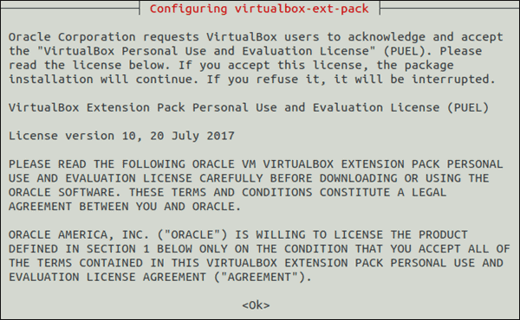

4. The installer asks you to agree with the terms of the VirtualBox PUEL license by selecting **Yes**.

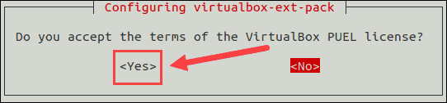

5. Wait for the installation to complete and then move on to the next step.

**Note:**For the VirtualBox hypervisor to work, hardware virtualization must be enabled in your system BIOS.

**Step 3: Install Kubectl**

To deploy and manage clusters, you need to install **kubectl**, the official command line tool for Kubernetes.

1. Download kubectl with the following command:

$ sudo apt-get update

$ sudo apt-get install -y kubectl

1. Verify the installation by checking the version of your kubectl instance:

$ kubectl version --client

**Step 3: Install Minikube**

With VirtualBox set up, move on to installing Minikube on your Ubuntu system.

1. First, download the latest Minikube binary using the **wget** command:

$ wget <https://storage.googleapis.com/minikube/releases/latest/minikube-linux-amd64>

2. Copy the downloaded file and store it into the **/usr/local/bin/minikube** directory with:

$ sudo cp minikube-linux-amd64 /usr/local/bin/minikube

There will be no output if the command was executed correctly.

3. Next, give the file executive permission using the [chmod command](https://phoenixnap.com/kb/linux-file-permissions" \t "_blank):

$ sudo chmod 755 /usr/local/bin/minikube

Again, there will be no output.

4. Finally, verify you have successfully installed Minikube by checking the version of the software:

$ minikube version

The output should display the version number of the software, as in the image below.

**Step 5: Start Minikube**

Once you have set up all the required software, you are ready to start Minikube.

Run the following command:

$ minikube start

First, the system downloads the Minikube ISO file from an online source and the localkube binary. Then, it creates a virtual machine in VirtualBox within which it starts and configures a single node cluster.

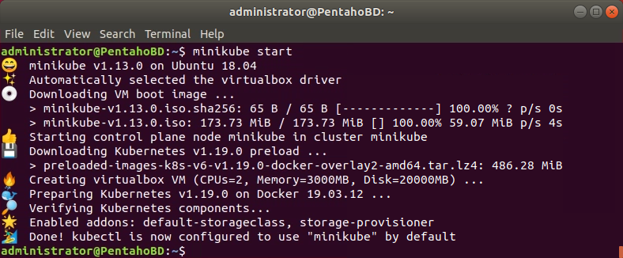

**Common Minikube Commands**

To see the kubectl configuration use the command:

$ kubectl config view

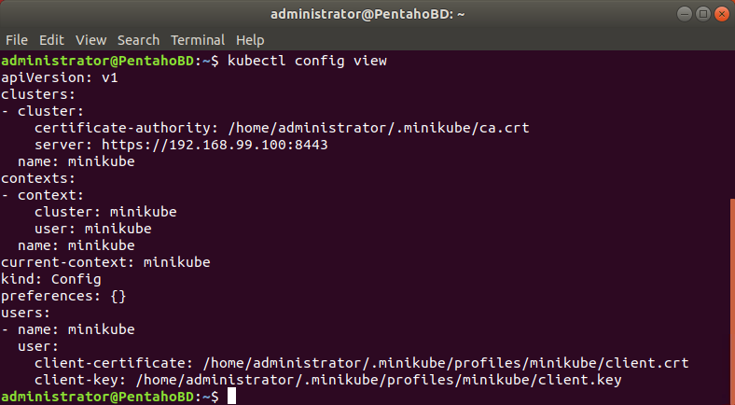

To show the cluster information:

kubectl cluster-info

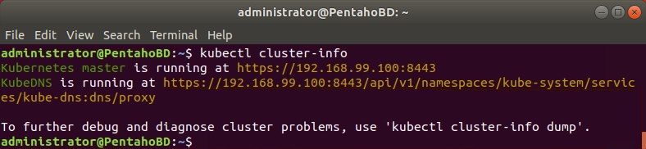

To check running nodes use the following command:

kubectl get nodes

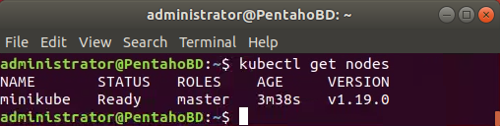

To see a list of all the Minikube pods run:

kubectl get pod

To ssh into the Minikube VM:

minikube ssh

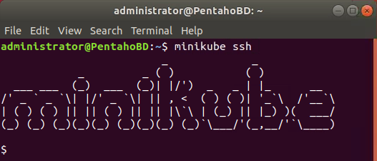

To exit out of the shell run:

exit

To stop running the single node cluster type:

minikube stop

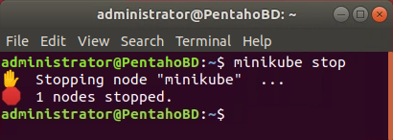

To check its status use:

minikube status

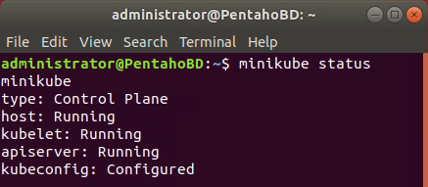

To delete the single node cluster:

minikube delete

To see a list of installed Minikube add-ons:

minikube addons list

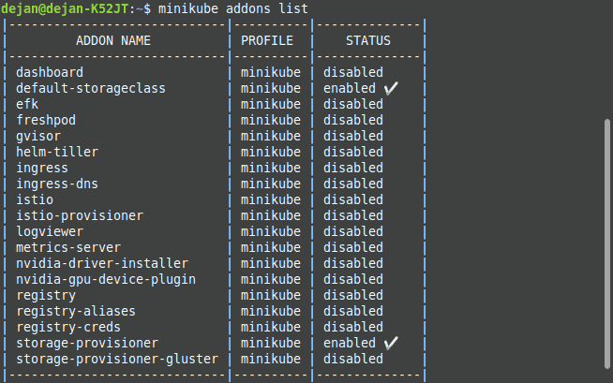

**Access Minikube Dashboard**

Minikube comes with a dashboard add-on by default. The web dashboard provides a way to manage your [Kubernetes cluster](https://phoenixnap.com/kb/what-is-kubernetes) without actually running commands in the terminal.

To enable and access the Minikube dashboard via terminal, run the following command:

minikube dashboard

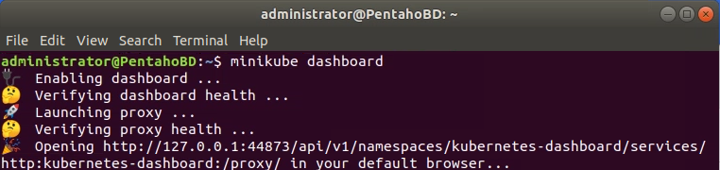

Once you exit the terminal, the process will end and the Minikube dashboard will shut down.

Alternatively, you can access the dashboard directly via browser.

To do so, acquire the dashboard’s IP address:

minikube dashboard --url

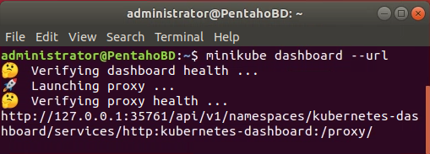

Access your Minikube dashboard by browsing to your dashboard’s IP address.

**Conclusion**

By following this article, you should have successfully installed and configured Minikube on Ubuntu 18.04 or 20.04. You can now test and master the art of Kubernetes on your local machine with the help of a single Minikube node.